**SQL**

# Data Modelling

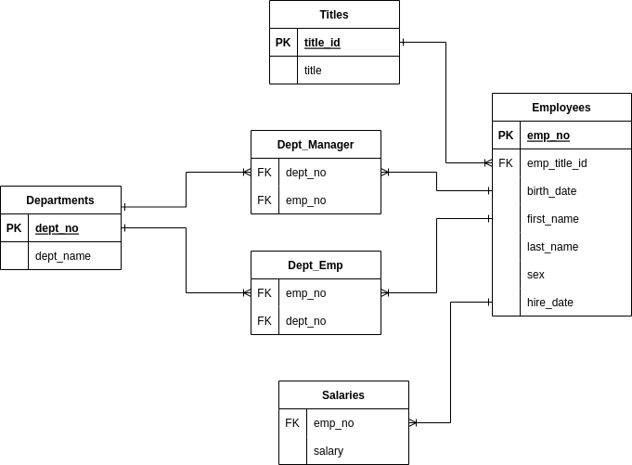

Figure : ERD

# Data Engineering

## Database Schema

CREATE TABLE `departments` (

`dept_no` varchar(50) PRIMARY KEY,

`dept_name` varchar(50) NOT NULL

);

CREATE TABLE `titles` (

`title_id` varchar(50) PRIMARY KEY,

`title` varchar(50) NOT NULL

);

CREATE TABLE `employees` (

`emp_no` int(11) PRIMARY KEY,

`emp_title_id` varchar(50) NOT NULL,

`birth_date` date NOT NULL,

`first_name` varchar(50) NOT NULL,

`last_name` varchar(50) NOT NULL,

`sex` char(1) NOT NULL,

`hire_date` date NOT NULL

);

CREATE TABLE `salaries` (

`emp_no` int(11) NOT NULL,

`salary` double NOT NULL

);

CREATE TABLE `dept_emp` (

`emp_no` int(11) NOT NULL,

`dept_no` varchar(50) NOT NULL

);

CREATE TABLE `dept_manager` (

`emp_no` int(11) NOT NULL,

`dept_no` varchar(50) NOT NULL

);

ALTER TABLE `dept_emp`

ADD CONSTRAINT `dept_emp_ibfk_1` FOREIGN KEY (`dept_no`) REFERENCES `departments` (`dept_no`) ON UPDATE CASCADE,

ADD CONSTRAINT `dept_emp_ibfk_2` FOREIGN KEY (`emp_no`) REFERENCES `employees` (`emp_no`) ON UPDATE CASCADE;

ALTER TABLE `dept_manager`

ADD CONSTRAINT `dept_manager_ibfk_1` FOREIGN KEY (`dept_no`) REFERENCES `departments` (`dept_no`) ON UPDATE CASCADE,

ADD CONSTRAINT `dept_manager_ibfk_2` FOREIGN KEY (`emp_no`) REFERENCES `employees` (`emp_no`) ON UPDATE CASCADE;

ALTER TABLE `employees`

ADD CONSTRAINT `employees_ibfk_1` FOREIGN KEY (`emp_title_id`) REFERENCES `titles` (`title_id`) ON UPDATE CASCADE;

ALTER TABLE `salaries`

ADD CONSTRAINT `salaries_ibfk_1` FOREIGN KEY (`emp_no`) REFERENCES `employees` (`emp_no`) ON UPDATE CASCADE;

# Data Analysis

List the employee number, last name, first name, sex, and salary of each employee.

SELECT

employees.emp_no as EmployeeNo,

employees.last_name as LastName,

employees.first_name as FirstName,

employees.sex as Sex,

salaries.salary as Salary

FROM employees

JOIN salaries ON employees.emp_no = salaries.emp_no

ORDER BY employees.emp_no;

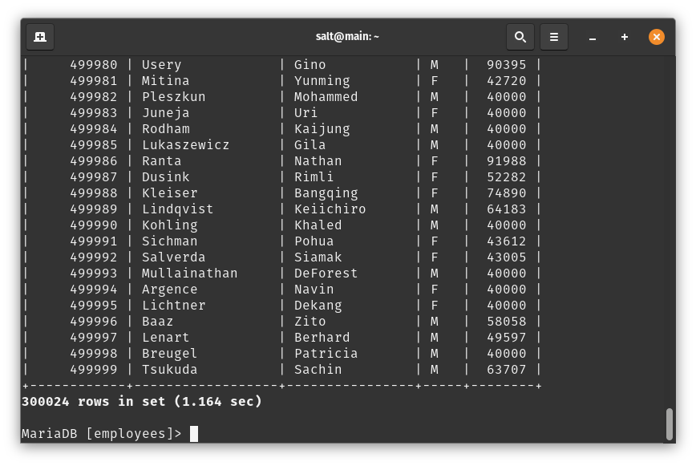

## 2.

List the first name, last name, and hire date for the employees who were hired in 1986.

SELECT

first_name as FirstName,

last_name as LastName,

hire_date as HireDate

FROM employees

WHERE year(str_to_date(hire_date,'%m/%d/%Y'))=1986

ORDER BY emp_no;

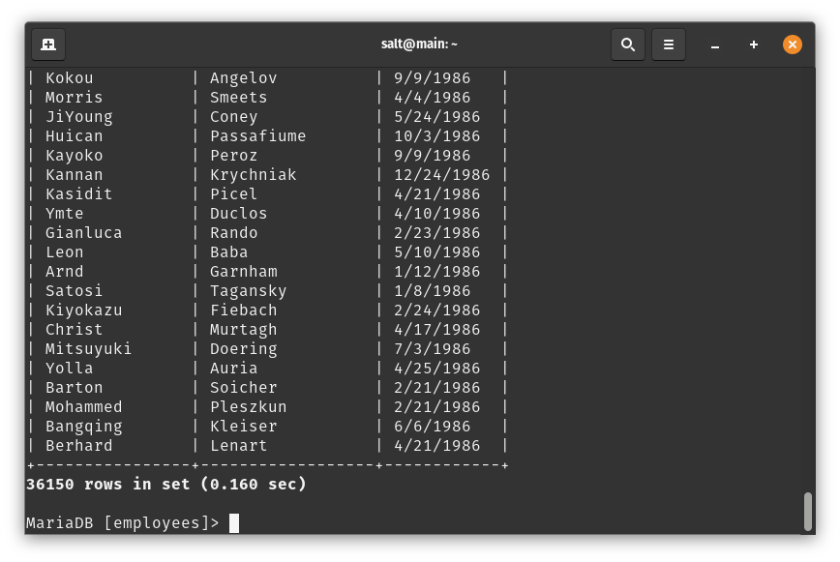

## 3.

List the manager of each department along with their department number, department name, employee number, last name, and first name.

SELECT

departments.dept_no,

departments.dept_name,

employees.emp_no,

employees.last_name,

employees.first_name

FROM departments

JOIN dept_manager ON departments.dept_no=dept_manager.dept_no

JOIN employees ON dept_manager.emp_no=employees.emp_no;

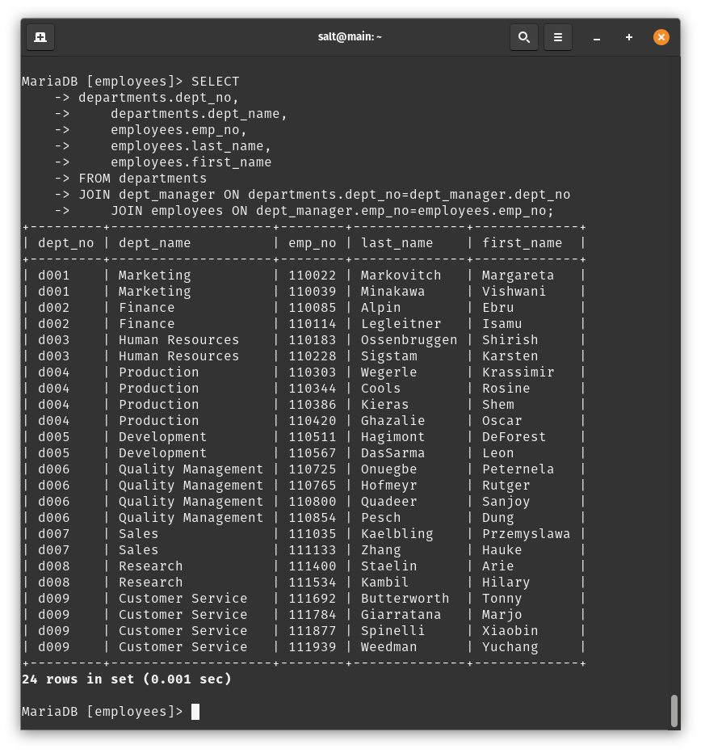

## 4.

List the department number for each employee along with that employee’s employee number, last name, first name, and department name.

SELECT

departments.dept_no,

departments.dept_name,

employees.emp_no,

employees.last_name,

employees.first_name

FROM departments

JOIN dept_emp ON departments.dept_no=dept_emp.dept_no

JOIN employees ON dept_emp.emp_no=employees.emp_no;

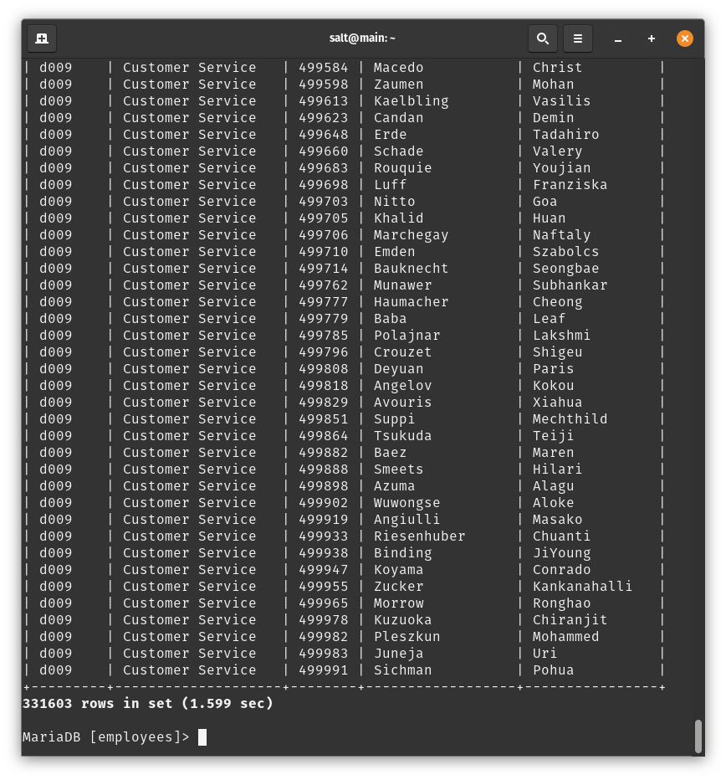

## 5.

List first name, last name, and sex of each employee whose first name is Hercules and whose last name begins with the letter B.

SELECT

first_name,

last_name,

sex

FROM employees

WHERE first_name='Hercules' AND last_name LIKE 'B%';

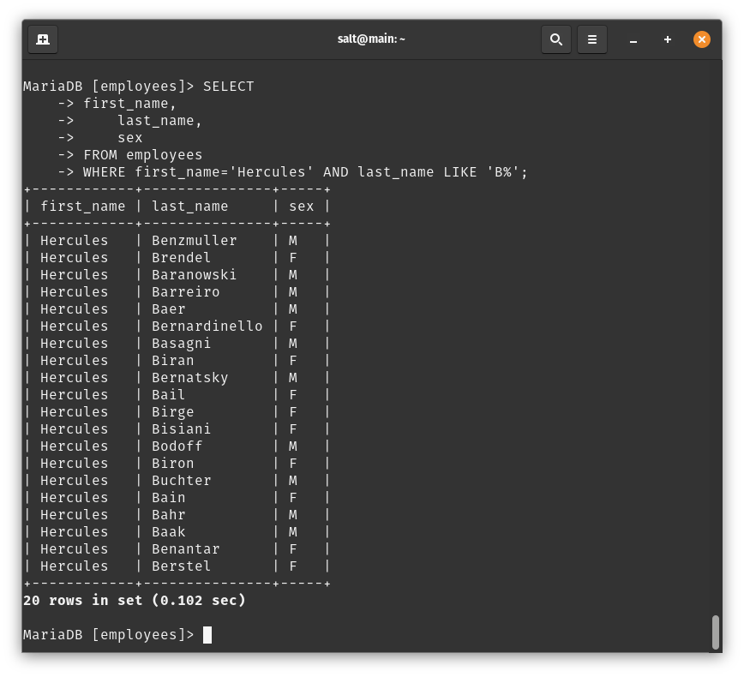

## 6.

List each employee in the Sales department, including their employee number, last name, and first name.

SELECT

employees.emp_no,

employees.last_name,

employees.first_name

FROM employees

JOIN dept_emp ON dept_emp.emp_no=employees.emp_no

JOIN departments ON departments.dept_no=dept_emp.dept_no

WHERE departments.dept_name='Sales';

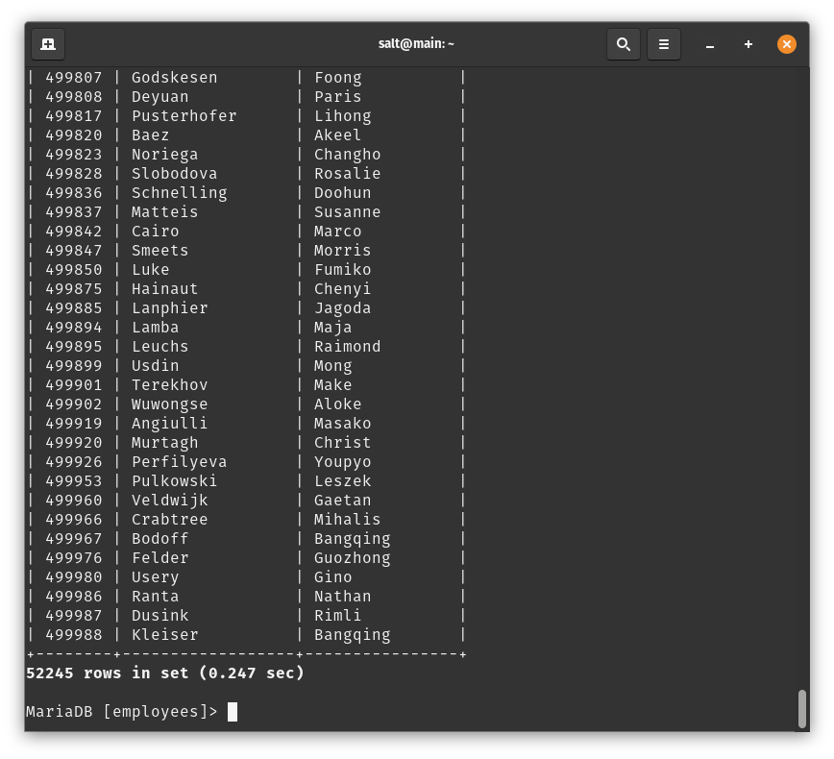

## 7.

List each employee in the Sales and Development departments, including their employee number, last name, first name, and department name.

SELECT

employees.emp_no,

employees.last_name,

employees.first_name,

departments.dept_name

FROM employees

JOIN dept_emp ON dept_emp.emp_no=employees.emp_no

JOIN departments ON departments.dept_no=dept_emp.dept_no

WHERE departments.dept_name='Sales' OR departments.dept_name='Development';

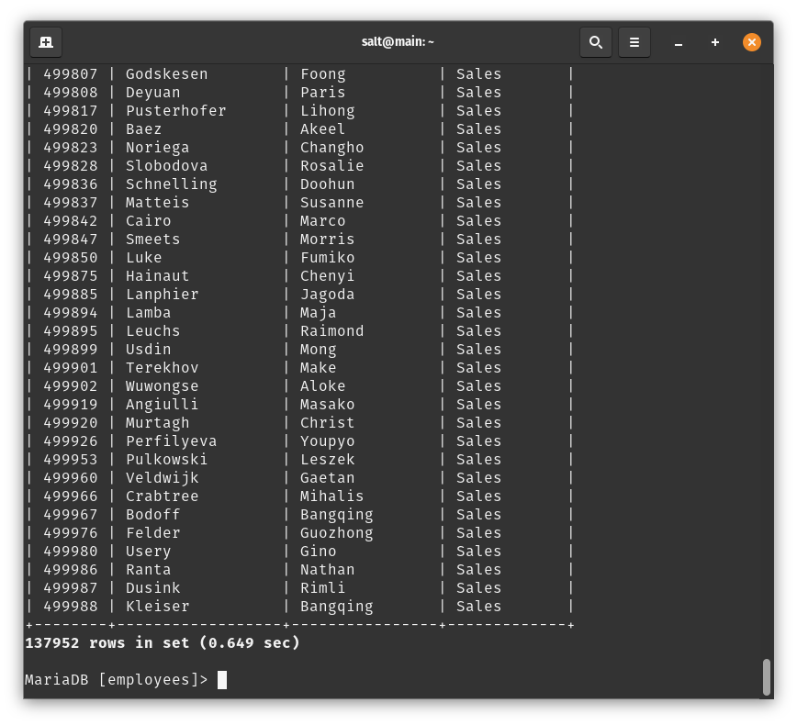

## 8.

List the frequency counts, in descending order, of all the employee last names (that is, how many employees share each last name).

SELECT

employees.last_name,

count(last_name) as Frequency

FROM employees

GROUP BY employees.last_name;

